O

Ladders and Step Ladders

Preventing Falls

- Read and follow the manufacturer’s instructions label affixed to the ladder if you are unsure how to use the ladder
- Inspect the ladder before using
- Do not use ladders that have loose rungs, cracked or split side rails, missing rubber foot pads, or are otherwise damaged
- If a ladder is found to be damaged or defective, it should be marked or tagged (“Do not use”) and sent for repair or replacement
- Place the ladder on a firm and level surface for use
- Use only grade #1 ladders on construction jobsites
- Keep ladder rungs clean and free of grease; remove buildup of material such as dirt or mud
- When using a ladder to get onto a roof, the top of the ladder must extend at least three feet above the roof surface
- The horizontal distance between the ladder and the wall should be ¼ the length of the ladder (i.e., a 12 foot ladder should be 3 feet from the building)
- When performing work from a ladder, face the ladder and do not lean backward or sideways from the ladder
- Allow only one person on the ladder at a time
- Do not stand on the top two rungs of any ladder
- Do not stand on a ladder that wobbles or that leans to the left or right
- Do not try to “walk” a ladder by rocking it; climb down the ladder and move it
- Face the ladder when climbing up or down
- Do not carry items in your hands while climbing up or down a ladder
- Maintain a three-point contact by keeping both hands and one foot or both feet and one hand on the ladder at all times when climbing up or down
- Ladders should be stored in clean, dry areas
- Do not use a ladder as a horizontal platform
- Do not place ladders on barrels, boxes, loose bricks, pails, concrete blocks, or other unstable bases
- Use the correct ladder for the task
- Be sure the load rating supports the weight of the user, materials, and tools
- Avoid using ladders with metallic components near electrical work and overhead power lines
- Do not use a ladder on a scaffold
- Do not use a ladder in high wind conditions
- Do not use a ladder as scaffold uprights

P1

Ergonomics: Lifting, Holding, and Motion Practices

Introduction

Ergonomics is study of the body’s movements and postures in relation to the performance of a certain task. Work-related problems can develop due to awkward postures, lifting, and wrist and arm movements in everyday work. Following are guidelines put in place in order to avoid injury related to lifting, holding, and other job-related motions.

Lifting

General

- Cut down on carrying by having materials delivered close to where they will be used
- Try to store materials at waist height
- Raise your work to waist level if you can
- Make sure floors and walkways are clear and dry
- Plan the move before lifting; remove obstructions from your chosen pathway
- Test the weight of the load before lifting by pushing the load with your hands or feet to see how easily it moves
- If the load is too heavy or bulky, use lifting and carrying aids such as hand trucks, dollies, pallet-jacks, and carts, or get assistance from a coworker (do not try to lift something that is too heavy for you!)
- If assistance is required to perform a lift, coordinate and communicate your movements with those of your coworker
- Never lift anything if your hands are greasy or wet
- Wear protective gloves when lifting objects with sharp corners or jagged edges
- Do not lift an object from the floor to a level above your waist in one motion; set the load down on a table or bench and then adjust your grip before lifting it higher

When lifting

- Position your feet 6 to 12 inches apart with one foot slightly in front of the other
- Face the load
- Bend at the knees, not at the back
- Keep your back straight
- Get a firm grip on the object with your hands and fingers; use handles when present
- Perform lifting movements smoothly and gradually; do not jerk the load
- Hold objects as close to your body as possible
- Try to carry the load in the space between your shoulder and your waist (this puts less strain on your back)
- If you must change direction while lifting or carrying the load, pivot your feet and turn your entire body; do not twist at the waist
- Set down objects in the same manner as you picked them up, except in reverse
- Do not arch your back if you are lifting a load over your head
- If you are lifting a number of things, take small breaks between lifts

Holding

- Try to keep your wrist in a neutral position (straight)
- Use your whole hand—not just your fingers—to hold objects
- If you can, switch hands often when you repeat movements
- Do range-of-motion exercises and stretches daily (see section P2)
- Be sure the grip size of any tools you are using is comfortable
- While working, wrists should be parallel and elbows should be at a 90 degree angle to your work surface
- Take breaks to stand, walk, and stretch
- Ask your doctor if a wrist splint is necessary
- Avoid direct pressure on the heel of the hand
- Gloves should fit properly and be made of a gripping material

Motion Practices

- Make adjustments in your work area so that your work is being done at chest level
- Avoid awkward positions for long periods of time
- Stretch periodically through out the day
- Alternate hands during a task, and rest them periodically
- Face your work directly to prevent reaching and twisting
- If you experience any of the following symptoms, notify your supervisor immediately:
  - Numbness
  - Constant fatigue
  - Cold hands
  - Swelling
  - Tingling
  - Lack of energy
  - Changes in skin color
  - Weakness
  - Loss of sensation
  - Aching, burning, or shooting pain

P2

Warm-up Stretches

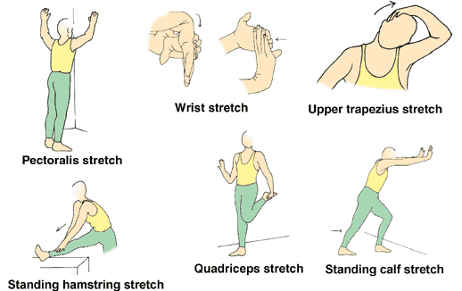

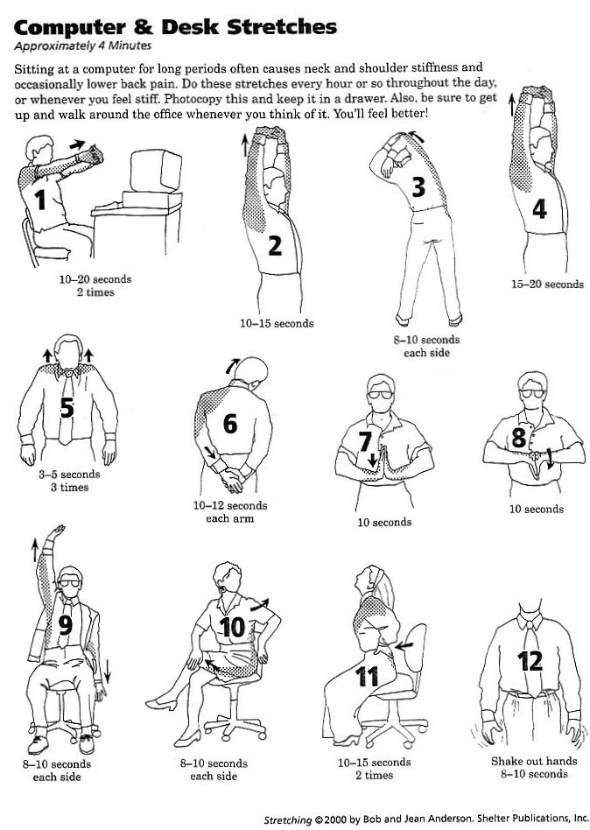

Q1
Heavy Equipment/Powered Industrial Trucks

Operation of Equipment

All Heavy Equipment

- Wear hardhats, hearing protection, steel toed boots, and protective eyewear while operating heavy equipment
- All operators must wear seat belts when operating heavy equipment or industrial trucks
- No passengers are permitted on heavy equipment
- Keep windows and windshield clean
- Do not use heavy equipment if its horn or backup alarm does not sound
- Do not crawl under the raised dump body during inspection of a dump truck
- Turn off the engine before leaving heavy equipment unattended
- Do not jump off of or onto any heavy equipment
- Do not stay in the cab of haulage vehicles while the payload is being loaded or unloaded by cranes or loaders
- When finished using power-shovels and backhoes, land the buckets on the ground, set the brakes, turn off the power, and shift the gear lever into neutral
- Do not enter the bucket swing radius while the equipment is in operation
- Keep heavy equipment in gear when going down grade; do not use neutral
- Display the “Slow Moving Vehicle” sign when operating heavy equipment on roads
- Do not operate backhoes, power shovels, or other heavy equipment within two feet from the edge of an excavation
- Do not work outdoors during lightening storms

Lifting Equipment

- Do not use chain slings if links are cracked, twisted, stretched or bent
- Fabricate all wire in wire rope slings by using thimbles; do not form eyes by using wire clips or knots
- Do not shorten slings by using make-shift devices, such as knots or bolts
- Do not use a kinked chain
- Protect slings from the sharp edges of their loads by placing pads over the sharp edges of the items that have been loaded
- Do not place your hands between the sling and its load when the sling is being tightened around the load
- Wear work gloves when handling rough, sharp-edged, or abrasive material, such as chains, cables, ropes, or slings
- Do not alter or remove the safety latch on hooks; do not use a hook that does not have a safety latch, or if the safety latch is bent
- Lift the load from the center of hooks, not from the point

Backhoe/Power-Shovel Operations

- Do not use a bucket or other attachments for a staging or temporary platform for workers
- Do not operate backhoe over or across underground utilities that are marked by paint, flagged, or staked
- Set swing brake of the bucket arm when moving the vehicle to and from the digging site
- Stay in the compartment during operation of the backhoe or power shovel; do not reach in or attempt to operate controls from outside the backhoe or power-shovel

Asphalt Paving

- Do not smoke or eat while performing asphalt paving work
- Do not mount or dismount paving equipment on the traffic side
- Always mount and dismount paver using installed walkways, steps, and handrails
- Do not leave loose tools, lunchboxes, or other items on operator’s platform

Utility Vehicle

- Do not misuse the utility vehicle; it is not a recreation vehicle
- Do not operate a utility vehicle on a frozen body of water
- Go slowly and be extra careful when riding on snow-covered or ice-covered terrain
- Slow down and be careful of traffic when operating near or crossing roadways
- Passengers should always use the hand holds
- All occupants must wear seatbelts
- Horseplay can lead to accidents and injuries, and is not allowed
- Sit on the center of the seat and keep both feet within the foot platform perimeter; clean foot platform if dirty, and remove any debris from around foot controls
- Check for debris in the engine compartment, especially around brake linkage on each side of the transaxle
- Always use both hands for steering
- Always back slowly
- Inspect the vehicle before operating; repair or replace damaged, badly worn, or missing parts
- Do not leave vehicle unattended when it is running

Laser Screed

- Be sure the area you are working in is well ventilated
- Relieve pressure before disconnecting hydraulic or other lines; tighten all connections before applying pressure
- When charging the battery, always remove the grounded (-) battery clamp first, and replace it last
- Use leak proof containers for holding drained fluids, such as oil, fuel, or coolant
- Do not mount tires without proper equipment and experience
- Do not exceed recommended inflation pressure on tires
- Never look directly into the laser beam
- To avoid an electrical short, always turn off the master switch when the machine is unattended
- Do not bypass safety devices, such as the Motion Alarm and Neutral Start Switches
- Avoid pinch-point areas, such as cylinders, gears, and latches
- Always use handrails and steps
- Do not walk on the boom

Telehandlers/Forklifts

- Forklift operators must be competent to operate these vehicles safely as demonstrated by their successful completion of training and evaluation; operators should have a valid forklift operator certification card
- No employee under 18 years old is allowed to operate a powered industrial truck
- Powered industrial trucks should be inspected daily for proper condition of breaks, horns, steering, forks, and tires (see inspection checklist)
- Powered industrial trucks should meet the design and construction requirements established in American National Standards Institute (ANSI) for Powered Industrial Trucks, Part II ANSI B56.1-1969
- Written approval from the truck manufacturer should be obtained for any modification or additions which affect capacity and safe operation of the vehicle
- Capacity, operation and maintenance instruction plates, tags or decals should be changed to indicate any modifications or addition to the vehicle
- Battery charging should be conducted in areas specifically designated for that purpose
- Material handling equipment should be provided for handling batteries, including conveyors, overhead hoists or equivalent devices
- Reinstalled batteries should be properly positioned and secured in the truck
- Smoking is prohibited in battery charging areas
- Precautions should be taken to prevent open flames, sparks or electric arcs in battery charging areas
- Employees will be given periodic evaluations of operating skills, and will be observed for unsafe operating practices
- Recertification is required every three years
- When a truck is left unattended, load and forks should be fully lowered, controls neutralized, power shut off, and brakes set
- There should be sufficient headroom for the forklift and operator under overhead installations, lights, pipes, sprinkler systems, etc.
- Trucks must be operated at a safe speed
- All loads should be kept stable, safely arranged, and fit within the rated capacity of the truck
- Unsafe and defective trucks should not be used and tagged “Out of Service”
- Backup alarms are required if the operator can’t see when backing
- A fire extinguisher should be kept on the truck if operating outside in an area where fire extinguishers are not present
- If the unit has a seatbelt, it must be used while being operated
- Service records regarding routine maintenance on the vehicle must be kept at the location
- Horseplay on or around powered industrial trucks is not tolerated

Cranes and Hoists

- Crane machinery and other rigging equipment should be inspected daily prior to use to make sure that it is in good condition
- Do not use load hooks that are cracked, bent, or broken
- Do not use cranes that do not have their rated load capacity indicated on each side of the crane or on its load block
- Cranes should be equipped with a load chart
- Operators should understand and use the load chart
- The operator should be able to determine the angle and length of the crane boom at all times
- Passengers are not permitted to ride inside the operator’s cab of a truck crane
- Keep crane windows clean; do not use a crane if its windows are broken
- Do not exceed the rated load capacity as specified by the manufacturer
- Do not operate a crane on soft ground without cribbing and mats
- Fully extend outriggers before attempting a lift
- Areas within the cranes rig should be barricaded
- If you are not operating the crane, stay outside the barricades of the posted swing radius
- Tag lines should be used to prevent dangerous swing or spin of materials when raised or lowered by a crane or derrick
- Illustrations of hand signals to crane and derrick operators should be posted on the job site
- Do not perform any crane refits or modifications without the manufacturer’s approval
- Do not leave the crane unattended with a hoisted load
- Do not hoist loads over people
- Wear high visibility vests before working as a signal person
- The signal person should use correct signals for the crane operator to follow
- Only follow the signals of the person designated to give you signals when operating a crane
- Replace the belts, gears, or rotating shaft guards after servicing a crane; do not use the crane if guards are missing from these areas
- Cranes and derricks are restricted from operating within 10 feet of any electrical power line
- The upper rotating structure supporting the boom and materials being handled should be provided with an electrical ground while working near energized transmitter towers

Q2
Recommended Hand Signals

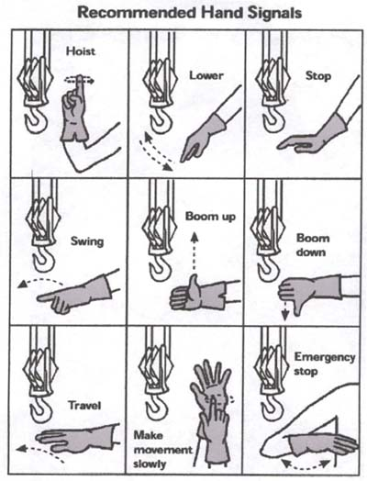

R
Driving and Vehicle Safety

Fueling Vehicles

- Turn the vehicle off before fueling
- Do not smoke while fueling a vehicle
- Wash hands with soap and water if you spill gasoline on your hands
- Don’t ever use cell phones when pumping fuel
- Never get back into the vehicle while fueling
- Touch a metal object (to discharge static from your body and prevent fire) before touching the gas nozzle

Driving Vehicles

- Shut all doors before moving the vehicle
- Drivers and all passengers must use seat belts at all times
- Obey all traffic patterns and signs at all times
- Maintain a three point contact using both hands and one foot or both feet and one hand when climbing into and out of vehicles
- Do not leave keys in an unattended vehicle
- Do not drive if you are fatigued
- Do not drive while under the influence of medications, alcohol, or drugs
- Do not use a cell phone while driving—pull over and stop the vehicle if it is necessary to use a cell phone
- Employees are required to immediately report job-related accidents to their supervisors or the Safety Coordinator

Vehicle Trailer Safety

- Perform a safety inspection before each trip and be sure that:
  - The pin securing the ball mount to the receiver is intact
  - The hitch coupler is secured
  - Spring bar hinges are tight with the safety clips in place (load equalizer or weight distributing hitches)
  - Safety chains are properly attached
  - The electrical plug is properly installed
- The tow vehicle must be a proper match for the trailer
- People are not allowed to ride in a trailer while it is being towed
- Trailers must be weighed to make sure that loads are properly distributed
- If you detect sway in your trailer, stop and check that your load is evenly distributed
- Be sure all trailer lights and signals are functioning properly
- Have another person help you when backing the trailer

S
Tool Safety
General

- Keep the blade of all cutting tools sharp
- Do not carry sharp or pointed hand tools—such as screwdrivers, scribes, chisels, or files—in your pocket unless the tool or pocket is sheathed
- Tag worn, damaged, or defective tools “Out of Service” and do not use them
- Do not use a tool if its handle has splinters, burrs, cracks, splits, or if the head of the tool is loose
- Do not use impact tools, such as hammers, steel stakes, or chisels that have mushroomed heads
- Do not perform “make-shift” repairs to tools
- Do not throw tools from one location to another or from one employee to another
- Transport hand tools only in tool boxes or tool belts; do not carry tools in your clothing
- Do not carry tools in your hand when climbing; carry tools in tool belts or hoist the tools to the work area with a rope or hand line
- Use tied off containers to keep tools from falling off of scaffolds and other elevated work platforms

Knives/Sharp Instruments

- Use knives for the operation for which they are made
- Do not use knives with broken or loose handles
- Do not use knives as screwdrivers or pry bars
- When handling knife blades and other cutting tools, direct sharp points and edges away from you
- Cut in the direction away from your body when using knives
- Do not use honing steels that do not have disc guards

Hammers

- Do not use a hammer if your hands are oily, greasy, or wet
- Do not strike nails or other objects with the cheek of the hammer
- Do not strike one hammer against another hammer

Snips

- Wear safety glasses or safety goggles when using snips to cut materials
- Wear work gloves when cutting materials with snips
- Keep the blade aligned by tightening the nut and bolt on the snips
- Do not use snips as a hammer or pry bar
- Use the locking clip on the snips after use

Chisels

- Keep the cutting edge of the chisel sharp
- Do not use chisels with damaged striking ferrules
- Hold a chisel with a tool holder if possible

Pliers

- Do not attempt to force pliers by using a hammer on them
- Do not use pliers that are cracked, broken, or sprung

Handsaws

- Keep control of saws by releasing downward pressure at the end of the stroke
- Do not use a saw that has dull saw blades
- Oil saw blades after each use
- Keep hands and fingers away from the saw blade while you are using the saw
- Do not carry a saw by the blade
- When using a handsaw, hold the work-piece firmly against the work table

Tool Boxes/Chests/Cabinets

- Do not use a tool box or chest as a workbench
- Use the handle when opening and closing a drawer or door
- Do not open more than one drawer of a tool box at a time
- Do not stand on tool boxes, chests, or cabinets to gain extra height
- Close and lock all drawers and doors before moving the tool chest to a new location
- Do not move a tool box, chest, or cabinet if it has loose tools or parts on the top
- Push large chests, cabinets and tool boxes; do not pull
- Lock the wheels on large tool boxes, chests, or cabinets to prevent them from rolling

Electrical Powered Tools

- Do not use power equipment or tools on which you have not been trained
- Keep power cords away from the path of power saws
- Do not use cords that have splices, exposed wires, or cracked or frayed ends
- Do not carry plugged-in equipment or tools with your finger on the switch
- Do not carry equipment or tools by the cord
- Turn the tool off before plugging or unplugging it
- Do not leave tools that are “On” unattended
- Do not handle or operate electrical tools when your hands are wet or when you are standing on wet floors or wet ground
- Do not use extension cords or other grounded three pronged power cords that have the ground prong removed or broken off
- Do not use an adapter that eliminates the ground, such as a cheater plug
- Do not drive over, drag, step on, or place objects on a cord
- Disconnect the tool from the outlet by pulling on the plug, not the cord
- Do not operate spark inducing tools—such as grinders, drills, or saws—near containers labeled “Flammable” or in an explosive atmosphere
- Electric tools should be double-insulated or have a 3-prong plug in a grounded outlet with a ground-fault circuit interrupter

Pneumatic Tools/Compressed Air

- Do not point a compressed air hose at bystanders or use it to clean your clothing
- Do not use pneumatic tools that have handles with burrs or cracks
- Lock and/or tag tools “Out of Service” to prevent usage of damaged or defective tools
- Do not use compressors if their belt guards are missing; replace the belt guards before using the compressor
- Turn the power switch of the tool to “off” and let it come to a complete stop before leaving it unattended
- Disconnect the tool from the air line before making any adjustments or repairs to the tool

Power Saws

- Wear the prescribed personal protective equipment such as goggles, gloves, dust masks, and hearing protection when operating the power saw
- Do not use a power saw that has cracked, broken, or loose guards, or other visible damage
- Turn off the saw before making measurements, adjustments, or repairs
- Keep your hands away from the exposed blade
- Operate the saw at full cutting speed with a sharp blade to prevent kickbacks
- If the saw becomes jammed, turn the power switch to “Off” before pulling out the incomplete cut
- Do not alter the anti-kickback device or blade guard
- When using the power saw, do not reach across the cutting operation
- When using the power saw, do not hold the work-piece against your body when making the cut
- Inspect the saw and the blade for cracks
- Saws must have a guard above and below the base plate
- Anyone using a saw should be properly trained in its usage
- Do not dry-cut masonry or stone
- Unplug the saw before you change the blade
- If you are cutting toward any wires, make sure they have been disconnected
- Make sure the saw blade is not touching anything before you turn on the saw
- Do not cut near flammable chemicals

T
Concrete Pumping

Concrete Pumping General Safety

- Personnel should recognize that air trapped behind a blockage in the hose can result in hose-whipping
- If a blockage is suspected, all personnel must move out of the end-hose movement area (the area within the radius of the last flexible piece of delivery system)
- Personnel should immediately notify the operator if a blockage exists or if they see that air has entered the system
- Personnel must heed the warnings from others and remain away from the point of discharge until the operator verifies that the hazard has been eliminated
- Wear the proper personal protective equipment when working near a concrete pump, including a hardhat, safety glasses, earplugs, gloves, and safety boots.

U
Office Safety
General Office Safety

- Don't lean back in your chair, and take the time to reach out and hold on to the chair as you sit down
- Keep the floor and walkway clear of electrical, telephone and computer cables, boxes, etc.
- Close one drawer in a filing cabinet before opening another
- Close the drawer in your desk before getting up, and close file drawers before walking away from the file cabinet
- Store supplies inside cabinets, not on top of them
- Store heavy items in lower drawers or on low shelves
- Watch out for slippery surfaces and clean up spills immediately
- Don't block your view by carrying loads higher than eye level.
- Don't read while walking
- Walk, do not run
- Don't climb on chairs, desks or boxes; use a step ladder instead
- Don't throw matches, ashes or cigarette butts into wastebaskets
- Don't overload wall sockets and extension cords
- Don't touch electrical switches, sockets, plugs, etc with wet hands
- Watch for unsafe conditions such as defective equipment, burned out lights, loose steps, torn carpet, etc and report them to your supervisor immediately

